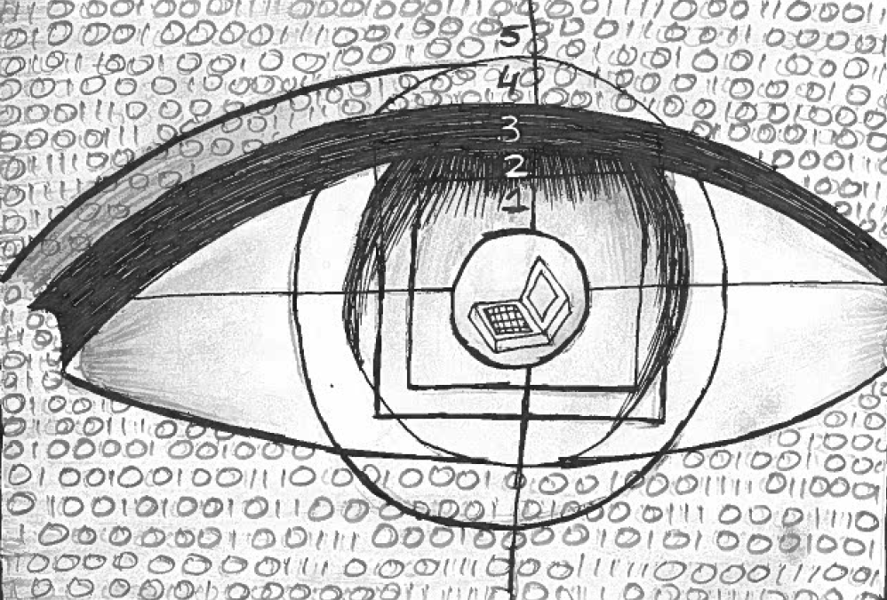

Prepared by

Geetanjali Agarwal(01)

Akansha Bathija(06)

Akshita Chawla(14)

Archana Deshmukh(18)

Mrinalini Dey(19)

Watumull Institute of Electronics Engineering and Computer Technology, Mumbai

October, 2014